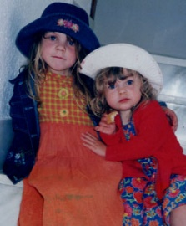

**QUEEN ADELAIDE**

What became of our wee Addy

Knee-high up against her sister?

Cast as Littl’un by her Daddy,

Blink and you might well have missed her.

But, behind those early un-assuming frames,

A Big Girls talent waits to be revealed.

Quick to pick up words and themes and names;

A mimic’s ear expands her social field.

At weekends and the free time after school -

Brownies, Guides and Skating at the Rink,

Elocution, Dance Floor and the Swimming Pool.

Everything to play, except the Kitchen Sink!

The school’s curriculum’s taken in her stride;

No subject, as it comes, beyond her means.

A quiver-full, with handy ‘A’s inside,

For Uni; now, her option’s open wide;

The world’s her oyster, that is how it seems.

She studies in the City home of John the Lennon,

And yet, there is an academic thirst -

An extra year in the land of Mao, the Chairman;

And then to finish with a glorious First.

For work, you settle for the Pennine west

Returning to your mother’s great-grandparent’s stock.

This is a move, surely, for the best

Lancastrian, Red Rose, tough as Blackpool rock.

Down Under, did you seek a Model Role -

In Adelaide, Prime of Southern Oz?

She’s really not a good choice on the whole

Don’t waste your time with her, because

As Consort to the hapless William Four

In ten years she could not provide an heir

Her husband fathered children by the score

And Silly Billy didn’t seem to care.

Better, far, to take a closer look at where you’re at!

The Queen that you should take to heart is the domestic cat.

Independent, quick to show affection –

This should point you in the right direction.

And, as you build your family tree, there is a date

That hardly needs to be the subject of attention

In Anno Domini Twenty Fifty-eight -

That’s when you start to draw your pension!

*A late Birthday Present. With Love*

*Grandpa Roger July 2022*