**O Brooklyn My Brooklyn.**

*Apologies to Walt Whitman.*

O Brooklyn My Brooklyn, what’s in a name;

A brook’s a small river that wends its own way;

So, a Brooklyn must be, if that’s all the same,

A very small river, what more can I say?

But, Giant Oaks from Little Acorns Grow;

And little brooks with varying contortions

Get wider, swifter, and sometimes, you know,

End up in estuarine proportions.

O Beckham, My Beckham, son of Dave and Vicky,

Brooklyn, they thought, - a clever message sender;

But in the end, things turned out rather tricky -

They’ve been and gone and picked the other gender.

O Brooklyn, My Brooklyn - off to live Oop North;

And if you want to spare yourself some hassle:

Two hints we offer as you venture forth -

Don’t marry Mister Bridge and call the place Newcastle.

O Geordie My Geordie, for that is what you are,

When you have swapped the Humber for the Tyne;

A ’Pet’ is not a budgie, scotty, moggy or a hamster

She’s just someone you meet from time to time.

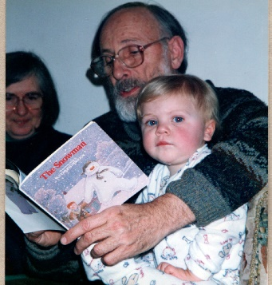

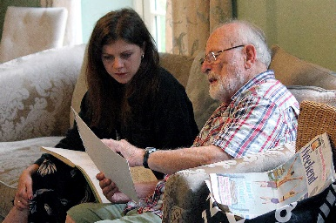

1996 2019

*Discuss the symbolism of The Snowman and Global Warming in a Post Brexit, Post Covid, Post Boris, Post Putin, Post Apocalypse age.*

O Snowman, My Snowman, by all the saints alive,

Hast thou a portent for Brooklyn thou durst mention?

Ay, by Anno Domini Twenty Fifty-five

She’ll show her age, as she begins to draw her pension.

*Grandpa Roger. August 2022*

*With Love. An early Birthday present.*

.